Project Design Phase-II
Technology Stack (Architecture & Stack)
Date | 14 July 2026
Team ID
Project Name | HouseRent India — MERN Property Rental & Sale Platform
Maximum Marks | 4 Marks

Technical Architecture:
The deliverable includes the architectural diagram below along with the component and characteristics tables.
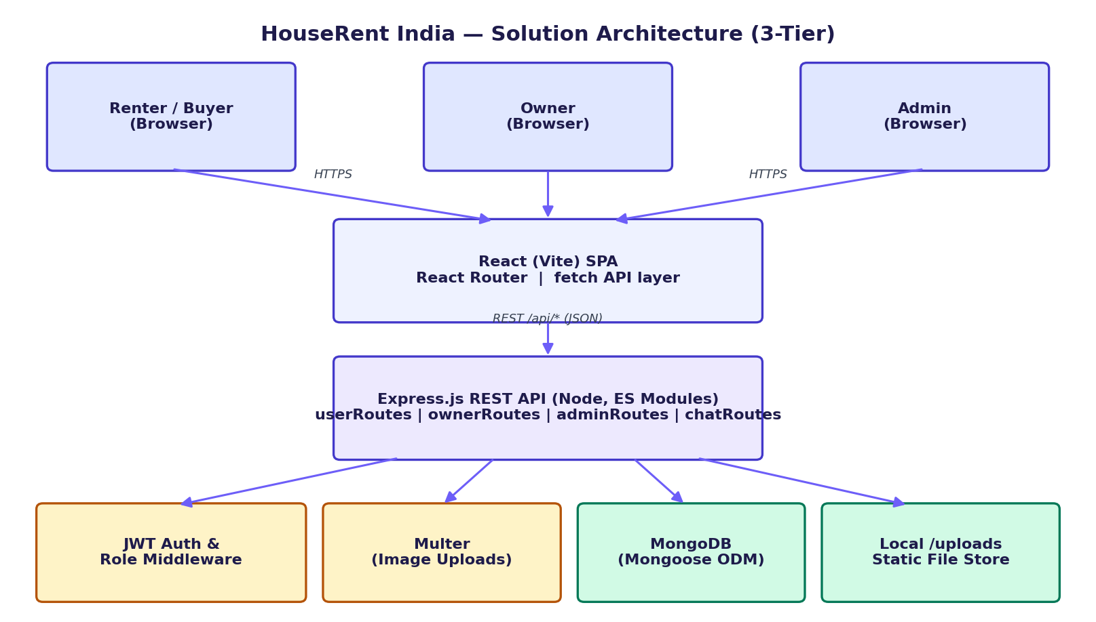
Figure 1: HouseRent India technical architecture

Table-1: Components & Technologies:
S.No. | Component | Description | Technology
1. | User Interface | How users interact with the application — Web UI (responsive SPA) | React 18, Vite, React Router 6, plain fetch
2. | Application Logic-1 | Authentication, role management, JWT issuance/verification | Express middleware (auth.js), jsonwebtoken, bcryptjs
3. | Application Logic-2 | Property listing CRUD, search & filtering | Express routes (userRoutes, ownerRoutes) + Mongoose
4. | Application Logic-3 | Booking lifecycle (create, approve, reject, cancel) and in-app chat | Express routes (userRoutes, ownerRoutes, chatRoutes)
5. | Database | Primary data store — users, properties, bookings, messages | MongoDB (Mongoose ODM)
6. | Cloud Database | Managed database hosting for production deployment | MongoDB Atlas
7. | File Storage | Property image uploads | Multer → local /uploads (server), migratable to cloud object storage
8. | External API-1 | None in current scope — planned: geocoding for map-based search | (Planned) Google Maps / OpenStreetMap API
9. | External API-2 | None in current scope — planned: SMS/OTP for stronger verification | (Planned) SMS gateway (e.g. MSG91, Twilio)
10. | Machine Learning Model | Not used in current scope | N/A
11. | Infrastructure (Server / Cloud) | Local dev: Node dev servers on :8000 (API) and :5173 (Vite).  Cloud: Server on Render/Railway; client's built dist/ on Vercel/Netlify. | Node.js runtime, Render/Railway, Vercel/Netlify

Table-2: Application Characteristics:
S.No. | Characteristics | Description | Technology
1. | Open-Source Frameworks | Full stack built on freely available open-source libraries | React, Express, Mongoose, Vite, React Router
2. | Security Implementations | Password hashing, token-based auth, role gating, input trimming/validation on schemas | bcryptjs (salted hashing), JWT, Express role middleware
3. | Scalable Architecture | Stateless REST API tier that can run multiple instances behind a load balancer; document DB scales horizontally with sharding as data grows | Express (stateless), MongoDB
4. | Availability | Frontend and backend deployed independently; static client assets served from CDN-backed hosting for high uptime | Vercel/Netlify (client), Render/Railway (server)
5. | Performance | Debounced live search on the frontend to cut redundant API calls; indexed MongoDB queries (e.g. compound email+role index, booking+createdAt index) | React state debouncing, MongoDB indexes

